VMS FY202021 Installation procedure
- Download the zip File from the following link
- https://ledger.treasury.go.ke/Docs/DVBK202021.zip
- Unzip the downloaded file in the C:\ drive in such a way that the following will be the final directory C:\DVBK202021
- Open the C:\DVBK202021 to view its content which should contain the following files
  - Data
  - DVBK.mdb
- Create a shortcut to the desktop for the DVBK.mdb and rename it to DVBK202021
- Create a safe location to run VBA macros and ActiveX controls for DVBK202021 in access for MS Office 2007 and earlier version as follows:
- Open a new Access application in your computer but do not create a database
- Click File/Home > Options.
- Click Trust Center > Trust Center Settings > Trusted Locations.
- Click Add new location.
- Click Browse to find the C:\DVBK202021, select the folder, and then check to the include subfolders and then click ok.
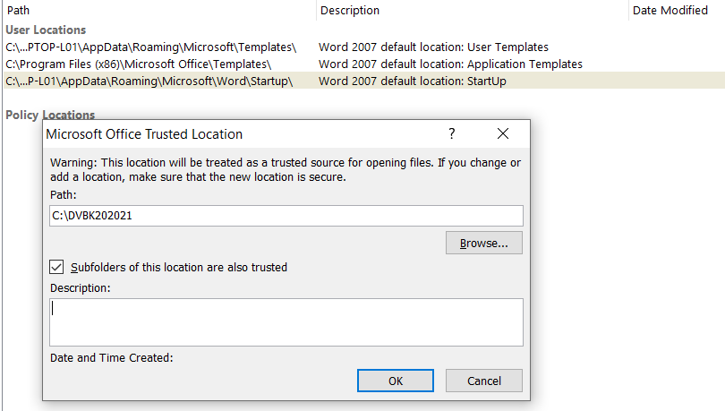
- Close the open Ms Access application
- Move back to drive C:\ and open the C:\DVBK202021\Data folder.
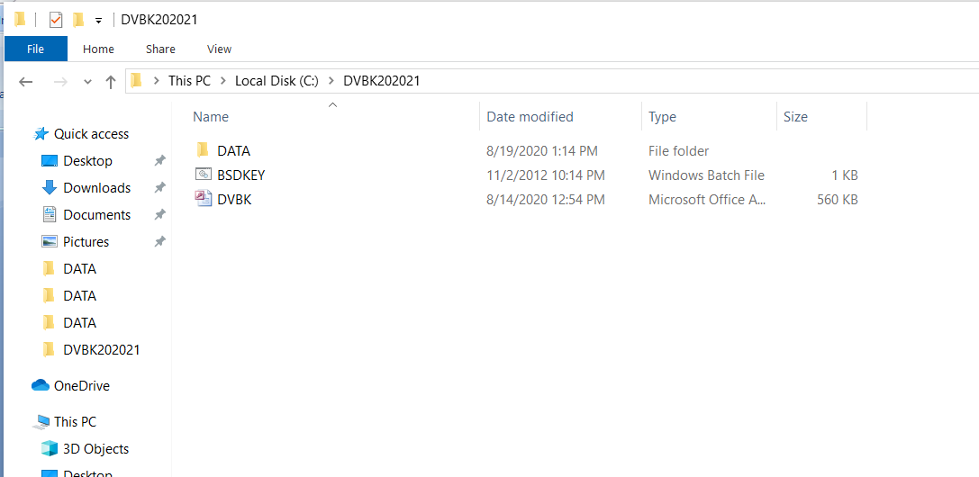

- Run the BSDKEY file by double clicking it.
NB if the BSDKEY fails to run or gives an error them move to step 9 other wise if it’s successful move to step 11
- Click the file and button and run the Powershell application in administrator mode
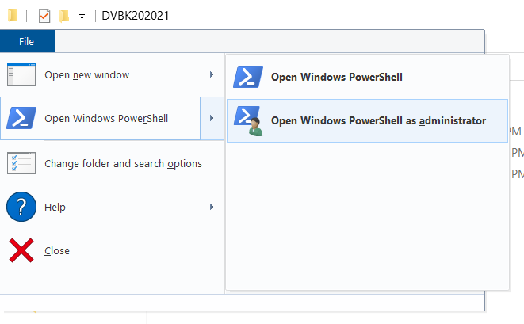
- Now run the following commands (get an ICT person to assist where possible)
copy /y .\data\Comdlg32.ocx %Systemroot%\System32
copy /y .\data\Comdlg32.ocx %Systemroot%\SysWOW64
copy /y .\data\7za.exe %Systemroot%\System32
copy /y .\data\7za.exe %Systemroot%\SysWOW64
copy /y .\data\7za.exe %ProgramFiles%\
copy /y .\data\RouterSim.ico %Systemroot%\System32
regsvr32 c:\Windows\SysWOW64\comdlg32.ocx
regsvr32 %Systemroot%\System32\Comdlg32.ocx
- Run the application from the desktop shortcut that you created in step 4 above
- Login into the application DVBK202021 ,The dammy account is Testuser and password is testuser
- Once logged in create the users in your Station from the Administrator Menu.
  - Click on Administrator menu
  - Re-Enter User name and password
  - Using the Manage Users form, add the officers Name, Personal Number and Designation
  - Add the user Responsibilities, Votebook, Deposit, Revenue, Etc
  - The users first password is welcome
  - The user will be prompted to change his/her password when he first logs in
- Now test the Export process, if the installation was successful after running the export you should fine the following created in your local drive C:\>>>>>>>>>>C:\Exports\2020\xxxxx.i4gz
For user with newer version of Ms Office from 2010-2019
- Edit Registry to record macros in Ms access before you create the trust center settings as follows
  - Run Regedit
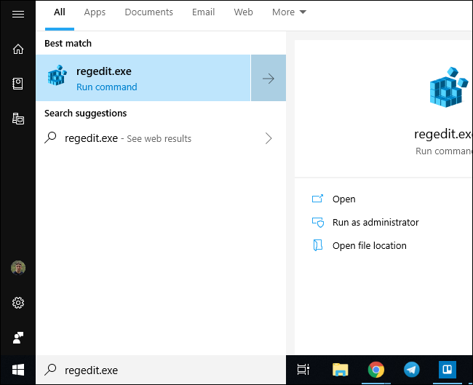

  - Navigate to Ms office registry entry shown

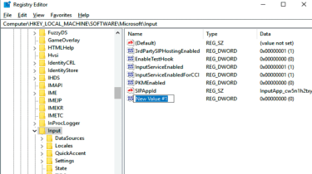

- Add a new Value Cmdlog and set it 1
- Close the registry and run the

Resolving challenges
While we expect that you will succeed in installing the Application for this year, we are also aware that some of the stations may face challenges. To report such challenges please send an email to
Pkahiro@ifmis.go.ke and a copy to franciskariuki35@yahoo.com

Error should be reported in the following format
Station | Windows version | Office Version | Brief Description of the Error Encountered
Kakamega | Windows 7 | Ms Office 2010 | - Computer Complaining of Unregistered Macros error 2078  Or  - My computer is not generating export file
Contact person: Name and Telephone Number
Sample Error reporting table

